LANDIS-II Visualization Tool v1.2

Extension User Guide

Johannes Liem1

Helen Jenny1

Melissa S. Lucash2

Robert M. Scheller3

1Oregon State University

2Portland State University

3NC State University

Last Revised: March 21, 2018

Table of Contents

1 Introduction 3

2 Selecting the data to visualize 4

3 Interactive Map Legend 6

4 Filtering Chart Data 7

5 Spatial Map Navigation 7

6 Temporal Animation and Navigation 7

## Introduction

This document describes the **Visualization Tool** for the LANDIS-II model. For information about the LANDIS-II model and its core concepts including succession, see the *LANDIS‑II Conceptual Model Description* and the LANDIS-II website ([www.landis-ii.org](http://www.landis-ii.org))*.*

## What’s new in version 1.2

In version 1.2, the tool has been modified to add a front screen with instructions (a help screen), “Load” button, and an information link (i) with additional hyperlinks that might be useful for the user.

## Major Releases

## Version 1.2

In version 1.2, the tool has been modified to add a front screen with instructions (a help screen), “Load” button, and an information link (i) with additional hyperlinks that might be useful for the user.

## Version 1.1

The only difference between this version and the previous version (1.0), is that the tool has been modified so the cell size of the maps does not have to be an integer.

## Version 1.0

This was the original release of LandViz.

## LandViz

## Overview of LandViz

This tool is designed to enable forest managers and other users to quickly and easily view maps and charts without using ArcMap or Excel.

For best results using the Visualization Tool, use the current Mozilla Firefox Browser or Google Chrome.

User Tip: The Visualization tool will not always work perfectly with Internet Explorer.

## Selecting the data to visualize

Use the website provided by the modeler to utilize the visualization tool. Click on the website to pull up the main menu (Figure 1). Initially there will not be any maps or charts displayed on your screen; only the main drop down menu will be shown on your computer.

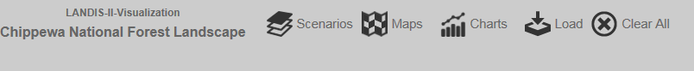

Figure 1. Drop down menus for dataset selection

To display a map or chart, click on the word “Scenarios” and then use the corresponding drop down menu to select which scenario you want to visualize. You can select one scenario (e.g. climate change scenario) or compare more than one scenario by selecting multiple scenarios in the scenario drop down menu (click in boxes to the left of the names).

Each scenario (e.g. climate change scenario) contains a number of datasets that can be visualized as maps or charts. Datasets are organized by LANDIS-II extensions in the drop down menus. To display maps, click on the word “Maps” to see what data is available. Use the check boxes to select the ones you want, and then click on the “Load” button to display the maps. To display charts, click on the word “Charts” and select the parameters of interest. Again, click on the “Load” button to load the charts.

Displayed datasets are labeled with extension (e.g. Output Leaf Biomass) and parameter name (Total Biomass Map, Figure 2). The maximum number of displayable maps (or charts) is four.

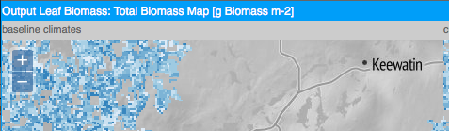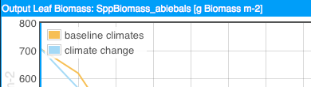

Figure 2. Labeling of selected datasets; extension name & parameter name

While a map can only show one parameter, a chart can show more than one parameter if more than one scenario is selected (Figure 3). A chart can not display more than one parameter within a scenario. If this is desired, then you should import the csv file into R or Excel.

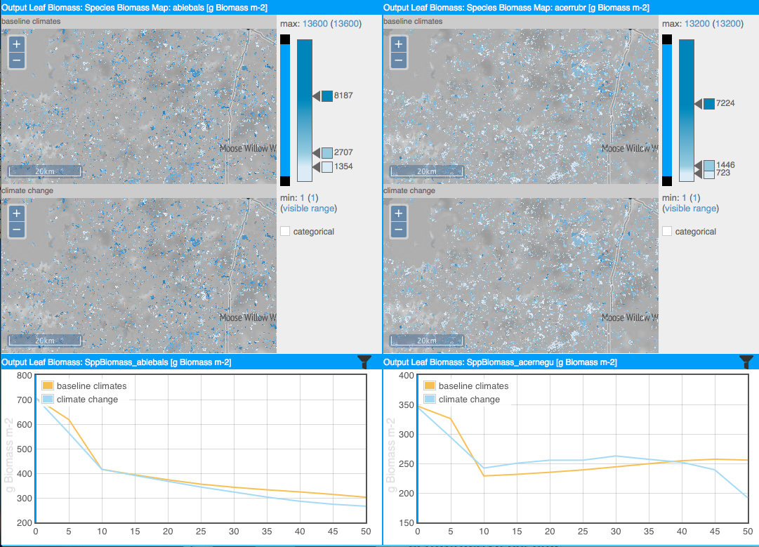

Figure 3. Two scenarios, two map parameters, and two chart parameters result in four maps and two charts.

## Using the Interactive Map Legend

You can adjust the classification bar (Figure 4 right) to set class breaks, add or remove classes, change colors, and switch between continuous (interpolated colors) and discrete color schemes (color bins). You can also adjust the filter bar (Figure 4 left) to adjust the maximum and/or minimum displayed on the screen.

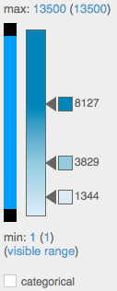

Figure 4. Map legend.

The default settings for the classification bar are calculated based on dataset statistics over the entire time period availability of the dataset; this is necessary to allow temporal animation. If more than one scenario is activated, statistics are calculated based on the entire time period and range of the parameter in all scenarios (Figure 5). For this reason, you may see a change in the classification when additional scenarios are activated. If different parameters are selected, one legend per parameter will be displayed.

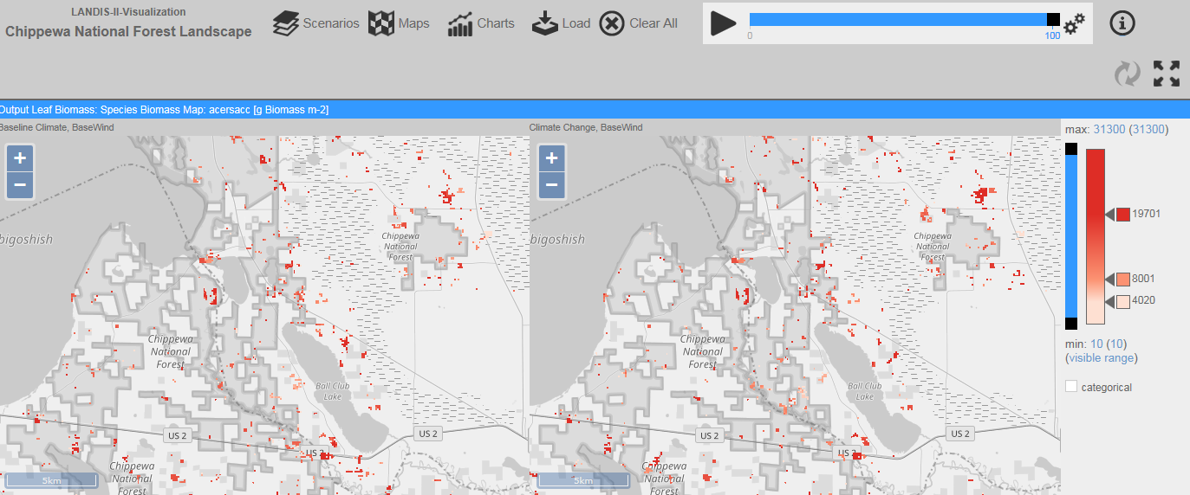

Figure 5. Two maps that share the same legend because they show the same parameter for two different scenarios.

To inspect the distribution of data in detail, you may want to change the classification. Double click the classification bar to add another class; double click a class break arrow to remove the class. Click a color square next to a class break arrow to assign a different data color to the class. Select the categorical option to switch to color bins. Drag the arrow next to a class break to move the break.

To filter map data to show only a certain data range, drag the black squares on the filter bar to adjust the visible range.

## Filtering Chart Data

To filter chart data, click the filter icon on the right of the chart’s title bar. Select a filter criterion and filter value to see a temporal chart for spatial areas that correspond to the filter value. Valid filter criteria are qualitative, e.g. ecoregions by ID and harvest prescriptions by name. The list of filters may contain invalid filter suggestions, usually quantitative parameters, which will produce an array of unique numbers that cannot be shown on the chart. The presence of these invalid filter criteria in the drop down menu is a trade-off to guaranty maximum tool flexibility; contact the software administrator if you are not sure which filter criteria are valid.

Figure 6. Filtering the data displayed on charts.

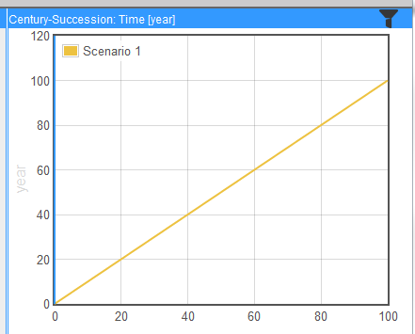

## Spatial Map Navigation

Use the plus and minus buttons to zoom in and out of the map. Available zoom levels are set by the software administrator at the time of creating the map tiles; zoom level limitations are a result of these settings. Click and drag to pan on the map. If you navigate in one map window, all other map windows will update to the new location and zoom level automatically.

## Temporal Animation and Navigation

Click the play button on the top menu bar to start a temporal animation.

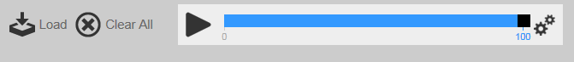

Figure 7. Playing a video of temporal changes.

On charts, the moving blue vertical line helps identifying parameter values that correspond to the current point in time. The maps are updated by displaying the map corresponding to the current time step; maps are not interpolated between time steps. Interactive legend and spatial navigation are enabled while the animation is running. Click on the gears symbol to the right of the temporal animation bar to adapt animation speed.

By default the playback interval is by year. If a parameter on a map has a time interval of 5 years, the map is updated every 5th year. Maps, where time steps are available only every 10 years, is updated every 10th year.

Select snap to greatest common interval in the gears menu to change the playback interval. If the first parameter has a time interval of 5 years and the second of 10 years, the playback time is based on the greatest common divisor (5 in this case). The playback interval is now 5 years.

## References

Gustafson, Eric; Lucash, Melissa; Liem, Johannes; Jenny, Helen; Scheller, Rob; Barrett, Kelly, Brian Sturtevant. 2016. [Seeing the future impacts of climate change and forest management: a landscape visualization system for forest managers](http://www.nrs.fs.fed.us/pubs/53235). Gen. Tech. Rep. NRS-164. Newtown Square, PA: U.S. Department of Agriculture, Forest Service, Northern Research Station. 18 p. <https://www.nrs.fs.fed.us/pubs/53235>

## Acknowledgements

Funding was provided by USDA AFRI (2012-68002-19896) and USDA Forest Service Northern Research Station. We acknowledge substantial contributions by the staff of the Chippewa National Forest, particularly Kelly Barrett, Jim Gries, Audrey Gustafson, Gary Swanson, Sharon Klinkhammer, Barb Knight, Rose Johnson and John Rickers. We also appreciate the help of Makiko Shukunobe, programmer at NC State who added additional features to LandViz in version 1.2.